SETUP FOR RUNNING SMA UMAT

# Abaqus Version, Visual Studio and Fortran Compiler

The tools used in the later simulation are Abaqus 6.14, Microsoft Visual Studio 2010, and Intel Parallel Studio XE 2011. In order to avoid compiling issues later on, it is necessary to make sure that the Abaqus version is compatible with visual studio and Fortran compiler. To do that, make sure the Abaqus can pass the ***abaqus verify -user_std*** from the Abaqus prompt command window as follows.

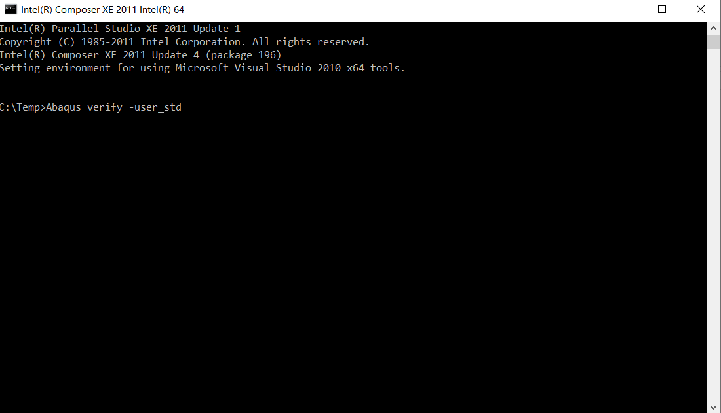

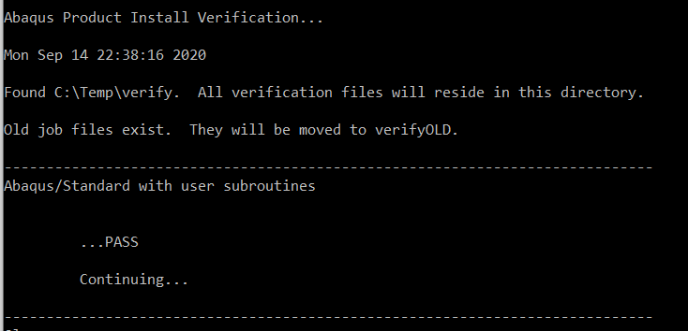

# Environment file

Replace the following environmental setup in the corresponding part in your abaqus_v6.env, this setup in the compiler is to make the compiler compatible with the UMAT format.

compile_fortran=['ifort',

'/c','/DABQ_WIN86_64', '/extend-source',

#'/fpp',

'/iface:cref', '/Qauto-scalar',

'/QxSSE3', '/QaxAVX',

'/heap-arrays:1',

'/Od', '/Ob0', # <-- Optimization Debugging

'/Zi', # <-- Debugging

'/include:%I']

# Run simulation

Open Abaqus, input one of the two .inp files from the attachment, (one is Bar_Actuation.inp for actuation case, another is Bar_Pseudo.inp for pseudoelastic case), Create a job and specify the path for the UMAT [Finite_Strain_SMA_UMAT.for](https://github.com/Aero-tomato/SMA-UMAT/blob/master/Finite_Strain_SMA_UMAT.for) you download from the Github website: <https://github.com/Aero-tomato/SMA-UMAT>. Run these jobs.

From the Bar_Pseudo.inp file, you should be able to get the following pseudoelastic response.

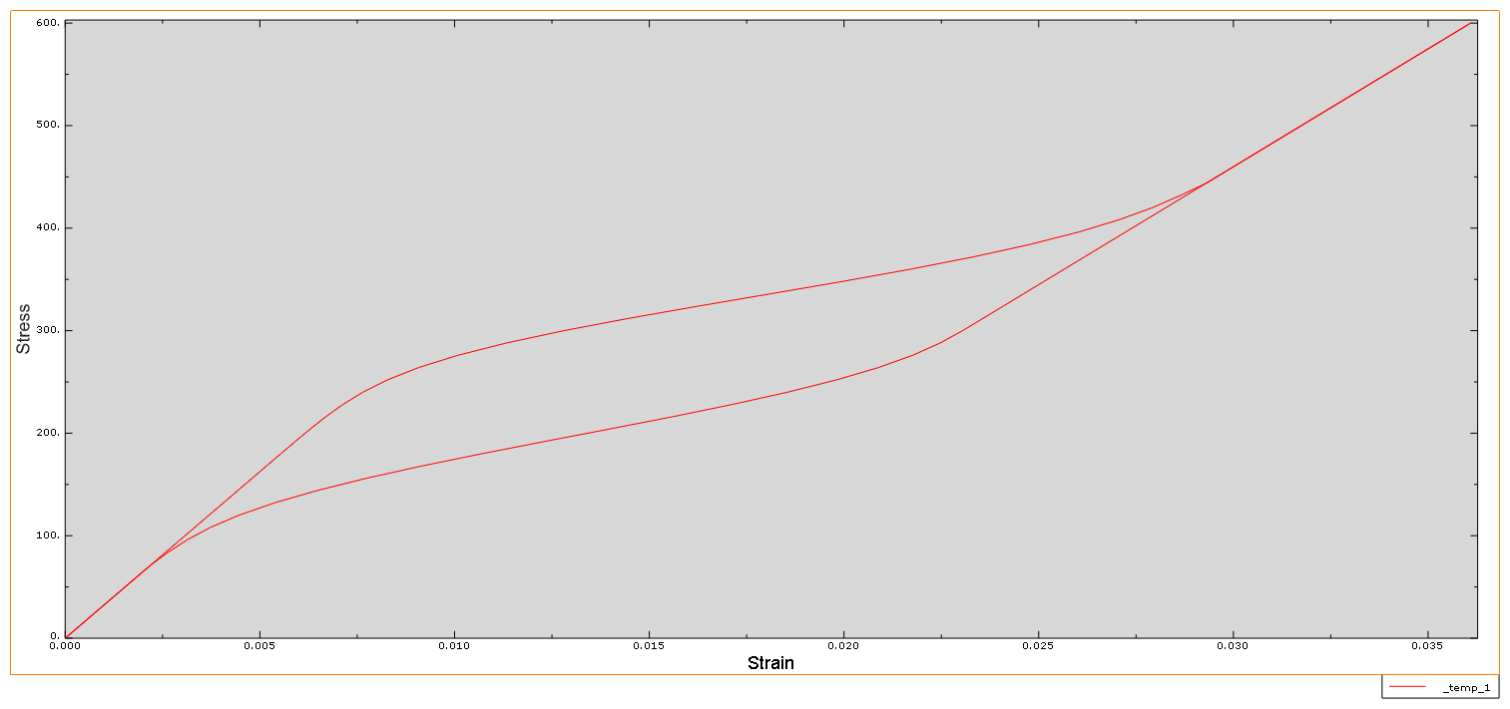

From the Bar_Actuation.inp file, you should be able to get the following actuation response.

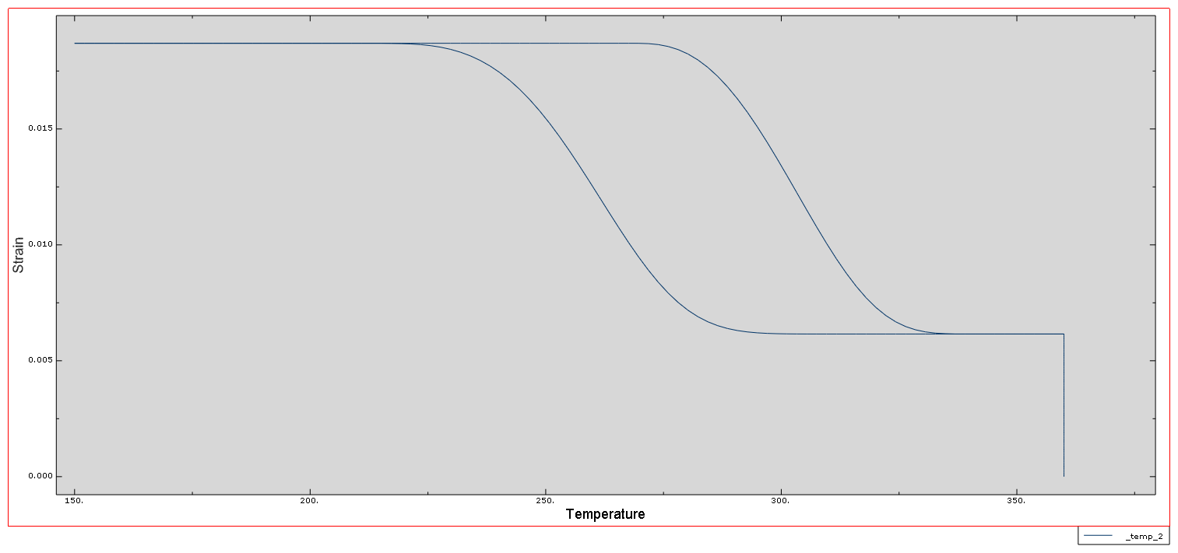

# Reference:

Xu, L., Baxevanis, T., & Lagoudas, D. C. (2019). A three-dimensional constitutive model for the martensitic transformation in polycrystalline shape memory alloys under large deformation. *Smart Materials and Structures*, *28*(7), 074004.

Xu, L., Baxevanis, T., & Lagoudas, D. (2018, September). A three-dimensional constitutive model for polycrystalline shape memory alloys under large strains combined with large rotations. In *Smart Materials, Adaptive Structures and Intelligent Systems* (Vol. 51951, p. V002T02A007). American Society of Mechanical Engineers.